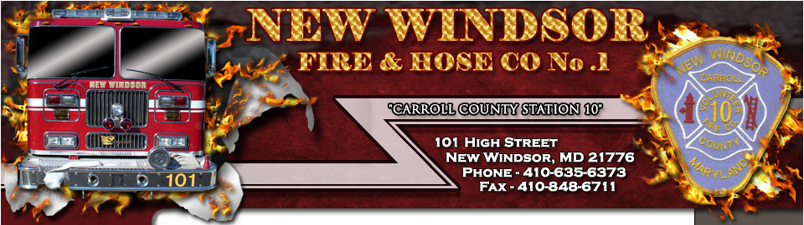

New Windsor Junior Fire Department – Who We Are
Purpose:
The purpose of the New Windsor Junior Fire Department is to provide young men and women with an opportunity to gain valuable firefighting and leadership skills in a fun, safe environment.
Values:
Teamwork: As part of the organization, members develop skills to work cohesively with other individuals for the common goal of learning how to protect the community and lead to a brighter future for all involved.
Responsibility: To accept the consequences, be they good or bad, for one’s own actions in preparation for life beyond school. It is the duty of the member to develop skills focused on the management of such responsibilities, both assigned and unassigned.
Respect: To honor the dignity and worth of all whom you come in contact with.
Leadership: Members will develop and hone skills necessary to lead others and act as a role model to those around you.
Service: To meet the needs of those in the surrounding community and develop the skills to exceed expectations.
Learning: To create an environment of learning and acceptance driven by interest and dedication leading to the development of firefighting and life skills.
Expectations:
It expected that members maintain good academic standing, both in school and voluntary courses; as education comes before extra-curricular activities. Members are expected to inform an advisor of any conflicts in schedule or necessary absences due to grades or school activities; these will not be counted against the member. In addition, it is expected that members will maintain proper conduct, both within the Junior Fire Department and outside of it. Above all else, since this is an activity oriented toward young members of the community, members will be encouraged to have fun, actively engage in learning opportunities, and develop new skills.
NEW WINDSOR JUNIOR FIRE DEPARTMENT

MEMBERSHIP APPLICATION

Name: _______________________________ Date _______________________

Phone # Home ____________________ Cell ________________________

Date of birth ______________ Age ____ SSN# _____________________

Address ___________________________________________________________

______________________________________________________________________

E-Mail ______________________________________________________________

Recommended by member Y/N Members name _________________

Applicants Signature ____________________________________

I certify that my child is between the ages of 12 & 18 and will obtain a work permit to be a member of the New Windsor Junior Fire Department. I also understand that there is a risk of injury while involved in the fire service activities.

Signature of Parent or Guardian ___________________________________

Parent or Guardian name: __________________________________________

Emergency contact information

Phone # Home ______________________ Cell _________________________

NEW WINDSOR JUNIOR FIRE DEPARTMENT

I give the New Windsor Junior Fire Department my permission to post my child’s picture on their Fire Department Web page.

Parent/Guardian Printed Name:______________________________________

Parent/Guardian Signature:__________________________________________

Member’s Name: _____________________________________________________

